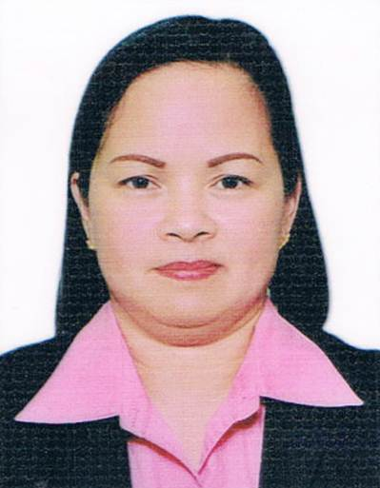
ELVIRA DIZON IROG

018 Sitio Maulawin
Brgy.Labuin,Sta.Cruz
Laguna
Philippines 4009
Contact Details:
+639064396522
elviradirog27@yahoo.com

POSITION APPLIED: Caregiver/nanny

WORK EXPERIENCED:

Mr Derek Bruce Davis ( private carer,84 years old) July 28,2011 to February 2,2015-London
Mr. Godfrey Macdominic (private carer,83 years old) November 2011 to September 2014-London
Mrs. Frieda Rose (private carer,93 years old) January 2010- September 2010(London,England)
Mr. Neil Rosen(part time cleaner,carer to his mum) February 2010-June 2011(London)
Mr.& Mrs. Norman/Minnie Russell (part time cleaner/carer to the couple) November 2010-August 2014(London)

Main Duties

1.Assistance with daily living of elderly clients
2. Administer bedside and personal care to the clients such as aid in ambulation,bathing,personal hygiene,and dressing and undressing.
3.Plan and prepare meals and special diets and assist in feeding if required.
4.Prepare and dispense medications.
5. May perform routine housekeeping duties such as laundry,washing dishes and making beds
6. Accompany to doctors appointments and therapies as needed.
7. shop for household and grocery items
8. Maintain a safe and healthy home environment
9. Keep records of activities and health related information related to client as needed

Part Time Nanny

Mr.&Mrs Roderick-MaryJane Arano(part time nanny/baby sit to Ella 4 mos to 3 years old(2010-2013)(London)
Mr.&Mrs Muhammad-Novielyn Fahim (part time nanny/baby sit to Farah and Rohan) 2010-2013(London)

Main Duties
1. Supervise the children,s activities at all times.
2. Plan and prepare meals and bottles for and feed the children
3.Dress the children
4.Place the children down for naps and bedtime
5.Bathe the children,change diapers, potty trained
6.Perform housework related to childcare,including washing the children,s clothes,cleaning up after meals,tidying play areas,and washing bottles
7.Teach children,both indoors and outdoors ,good social manners
8.Discipline children when necessary,administer medicine to the children

EDUCATIONAL ATTAINMENT:
6 Months Caregiver Course
Philippine Women,s University
Sta.Cruz Laguna Branch
Philippines
November 10, 2003- July 11,2004

COMPUTER SECRETARIAL(2 years-vocational)
Advanced Computer Training School, Incorporated
Sta.Cruz, Laguna
Philippines
June 1989-April 1991

PERSONAL INFORMATION:
Birthdate: December 27,1971
Age: 43 years old
Nationality: Filipino
Marital Status: Partner
Children: Justine Junel Tobias(21 years old)
Sean Harley Tobias (12 years old)

